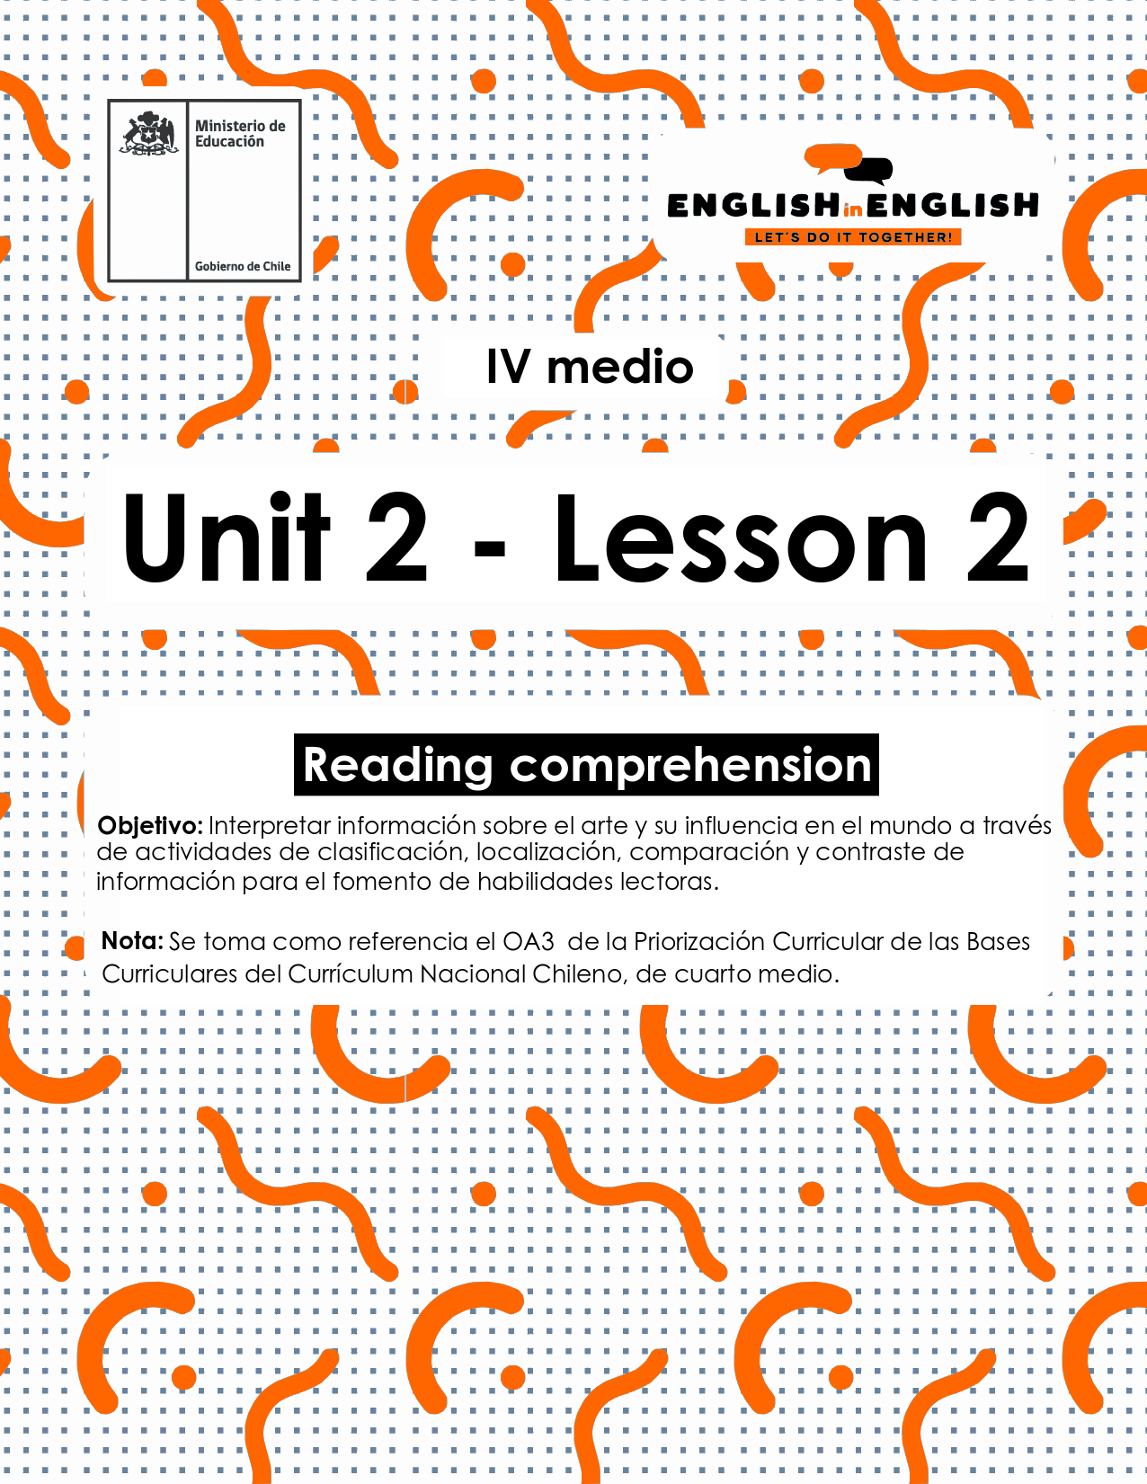

UNIT 2
LESSON 2

ÚTILES

- Texto del estudiante de 4° medio.
- Diccionario de inglés.
- Lápices.
- Cuaderno de asignatura.

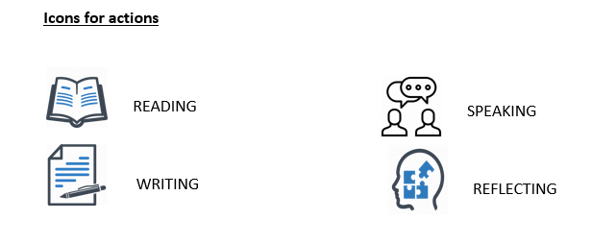

Hello students! Welcome back to lesson 2! In this lesson we will be practicing and learning about the arts and their influence.

SECTION 1: SETTING THE CONTEXT

The use of WH questions and the expression of preferences.
- We use WH Questions in English to make questions.
- Answer the following WH questions with your own personal information.

- What is your name? _____________________
- How old are you? _______________________
- Where do you live? ______________________
- Who is your role model in life? _____________________________
- and Why? ____________________________________________
- When were you born? ___________________________________
- How many brothers or sisters do you have? _____________________________________________________

Notice that all these questions are “WH questions”, and they are useful to gather information about anything you would like to know. In this case, for example, they are useful to ask about personal information.

- In English, as in Spanish, we use different verbs to express preferences. For example, like, love, prefer, enjoy, hate or don’t like are verbs to express preferences. Can you write the verb for the corresponding emoticon?


SECTION 2: LET’S PRACTICE! 
- Do you like movies? Or do you prefer music?
- Let´s read about our friend Paola´s preferences:

Hello, I am Paola from Colombia. Do you want me to tell you about me? Well, let´s see! I don’t have a preference really! I like music a lot, and I love watching movies too. I think they are both fantastic forms of artistic representation. However, I have to say that I don´t like all kinds of music or movies. For example, I don´t enjoy listening to music from the 80’s, and I really hate watching Zombie movies because I think they are bizarre.

From my country, I really like Shakira, she’s one of the best Colombian singers and she’s very famous. She has many songs with other artists like Rihanna and Maluma, another famous Colombian reggaeton singer. Do you know J. Balvin? He is also another Colombian famous reggaeton singer, although he’s not one of my favorites. Everyone says that Shakira changed her style because she used to sing pop music and write very interesting and meaningful songs, but now she mostly sings with reggaeton artists and she does not sing pop anymore. I think she just adapted her style to attract more people, but I don’t really judge her musical style, I mean, everyone is free to sing or listen whatever style they like. Anyway, as for movies, I like horror movies. For example, there is a Colombian paranormal movie called “At the end of the spectra” which I loved, and it was very famous in Colombia. The opening night the cinemas were full, and the movie was so much fun! I love paranormal movies, but zombie movies or vampire movies are not my favorites. They are just so fantastic and unreal!

- Do you remember Paola´s opinion about her arts preferences?
- Can you tell us about yours?
- Remember to use expressions such as I like/don`t like/enjoy/hate/etc.
______________________________________________________
______________________________________________________
_______________________________________________________
_______________________________________________________

- Let us keep on working!
- Read about what some artists said related to the world of arts.
- Check the alternatives and cross out the correct one according to each text:
“A big number of people tend to reject and stereotype teenager's music as nonsense or too loud...For them, some artistic manifestations should follow certain classical patterns. Why? Maybe, they were raised in such a structured way that it gets hard for them to accept or value new tendencies. In other words, they find it difficult to............... new artistic manifestations”, the musician mentioned.
- Enjoy
- Hate
- None of the above

- “I am really fond of painting. Every time I do it, I feel free to create and share my feelings through colours and palettes. I cannot describe the way my heart jumps when my art class begins!” Painting things like animals, butterflies or open spaces are my favourite. About styles, I would say Pop and Realism Art are the ones I love the most, but the Impressionism and Futurism are not part of my creations”, said the painter.
Summing up, the painter...
- Enjoys painting but hates Pop Art.
- Can`t stand Impressionism and Realism Art.
- Loves Art classes and two painting styles.
- “Painting, sculpture and architecture are the three classical branches of art. Other performing arts like dance, music, theatre and literature are also considered as part of the definition of the arts. Which one do you like best?” Asked the actress.
In other words, according to the actress, how many forms of arts are there?
- Only 3
- All the ones mentioned in the paragraph
- It does specify

- “Why do we like music so much? Maybe, it is our preferred way to get in touch with feelings or emotions. It certainly can make you feel sad or happy, bored or even exited! Anytime you might listen to a song you could start singing along without explanation. How many times have this happened to you?” Questioned the composer.
In a few words the composer said that...
- Music may change your mood.
- Music should help you memorizing lyrics.
- Music might influence your mood and make you do things unconsciously.

- The time to express yourself has finally arrived! Read the following statements and write down your opinion about them:

- If you can´t stand norms, you will never fit in.
1. ____________________________________________________
2. ____________________________________________________

- If someone loves sculpture, that immediately will make him or her a good sculptor.
1. _____________________________________________________
2. _____________________________________________________
- When you really hate doing something, it is impossible to do it well.
1. ____________________________________________________
2. ____________________________________________________
- I really love the free recreational facilities in my neighbourhoods, I have meet lots of new people there.
1. _____________________________________________________
2. _____________________________________________________

SECTION 3: LET´S CONSTRUCT AND APPLY OUR KNOWLEDGE

- How much do you know about music?
- Can you complete the following chart with information about these artists?
- Write short answers.

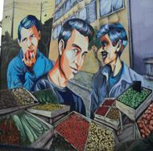 |  |  |  | 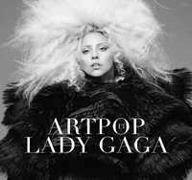
Who are they? | Los Prisioneros | What is her name? |  | How many albums does she have?
What are their names? |  | Where is she from? |  | How old is she?
Where are they from? |  | How old is she? |  | Who has she collaborated with?
Who is the lead singer? |  | Where did she start her TV career? |  | What do you think about her music style?

SECTION 4: EXTRA ACTIVITY

- By considering your favourite artist in the world.
- Can you create a visual representation of what you love, like and prefer the most about him/her/them?
- After that, can you explain in your own words?
- See the example for our favourite Chilean artist.
- This visual representation was created with Microsoft Power Point.

Violeta Parra (1917-1967)
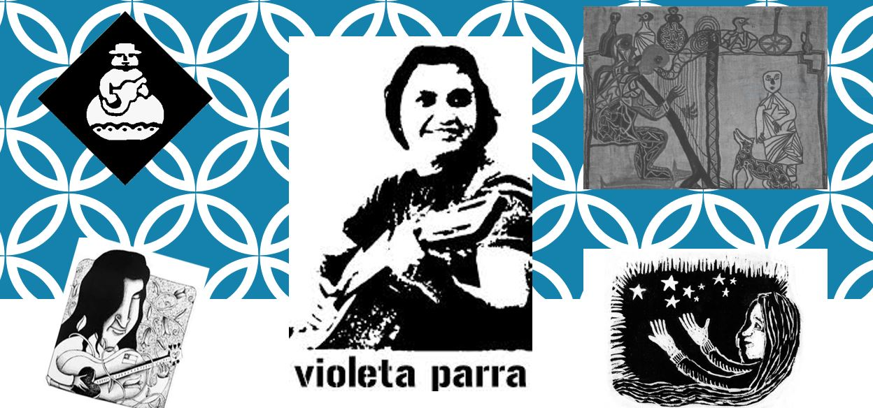
We Love Violeta Parra. We believe that she was unique, talented and such a complete artist. She used to sing beautiful songs, create amazing paintings and Art Craft. We also like the way she expressed her felling with her guitar and voice...

