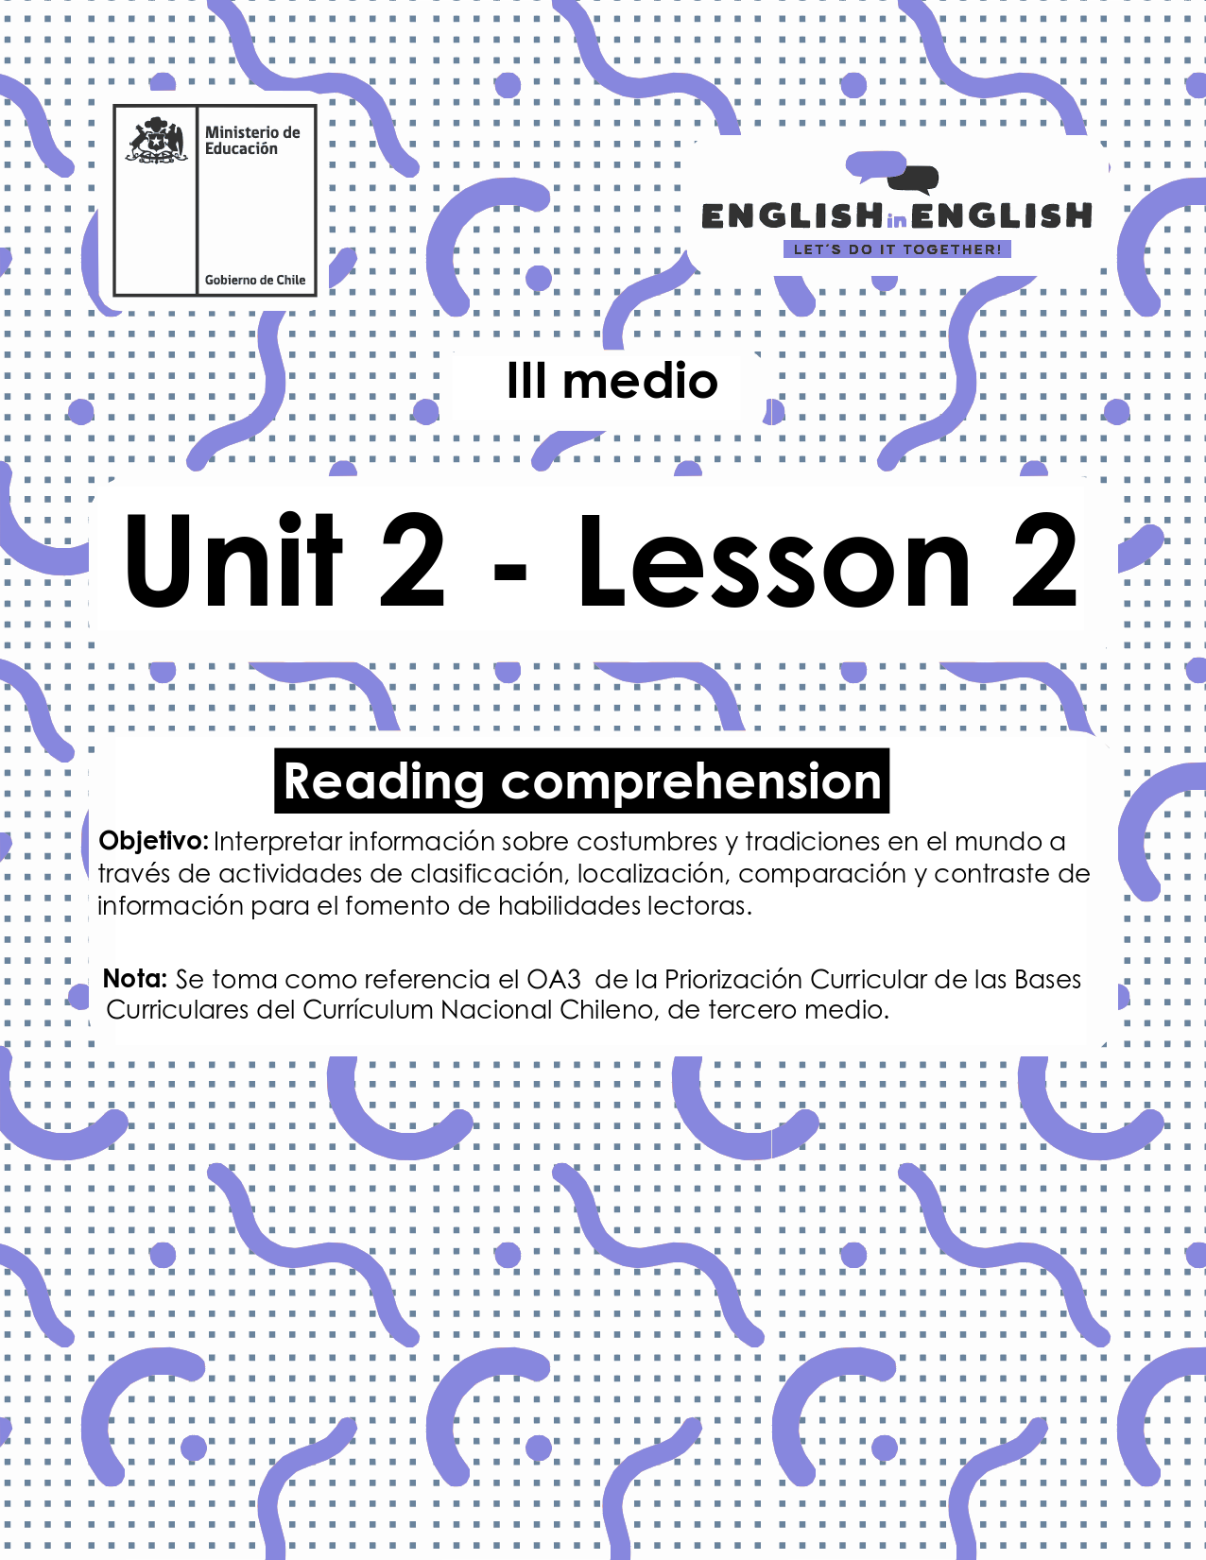

UNIT 2
LESSON 2

ÚTILES

- Texto del estudiante de 3° medio.
- Diccionario de inglés.
- Lápices.
- Cuaderno de asignatura.

ICONS FOR ACTIONS

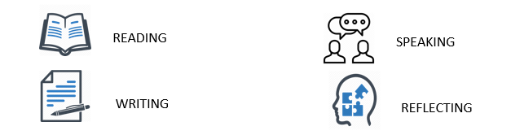

SECTION 1: SETTING THE CONTEXT: 

Differences between an opinion and a fact and uses of modal verbs.
Hello students Welcome back to lesson 2! In this lesson we will be practicing and learning about Costumes and Traditions all over the world.

- In English we use modal verbs to express obligation, to express possibility, to express (un) certainty and to give advice and recommendation as the following table shows:
Modal verb | For what? | Example
Must | to express obligation | You must wash your hands frequently over the corona virus pandemic
May | to express possibility | He may come tomorrow  He may not come tomorrow
Should | to give advice and recommendation | You should keep social distancing at work and school
Might | express (un) certainty | Corona virus might end by 2021  This is less possible or uncertain

- Look at the following images and complete the sentences with an appropriate modal verb

- Bart you _____clean your room. | 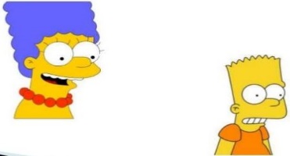
- It ______rain | 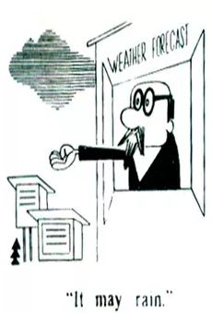
- It ______rain. | 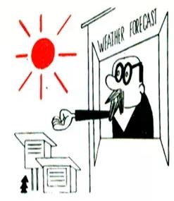
- You _______go to the doctor Patricia. | 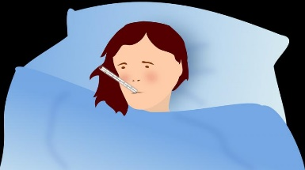

- Do you remember the difference between a fact and an opinion from last week worksheet?

- Well, a fact is something that can be checked and backed up with evidence, while an opinion is based on a belief or view.
- Can you classify these sentences into these two boxes?
- Complete the following table by rewriting the sentences under the corresponding column.

- National holidays’ celebrations may be cancelled this year.
- We have won the battle against coronavirus in South America with the C.19 vaccine
- Corona virus might end by the end of the year.
- Students are attending online classes.
- We are currently in obligatory quarantine.
- Most researchers said that we must practice social distance and quarantine to avoid spreading corona virus.
 | 

SECTION 2: LET´S PRACTICE 

Keywords
Instead: on the contrary
Attend: go to
Sedentary: not active
Schedule: Hours and time of the day to do certain activities
Get along with: Have a good relationship with

- Now, it is time for you to read and apply all you have reviewed about the use of modal verbs, facts, and opinions.

Teenagers in Quarantine
How do teenagers live in quarantine? Two Italian researchers investigated how Italian teenagers are living their quarantine, working with them through pictures and information. Some can’t wait to go out again, others don’t really want to, happy to stay home connected to the outside world only through their computer. Some are worried about the virus and others, instead, are more concerned about the climate crisis.
To give an answer to this important question, the researchers adopted the same ways that teenagers use to study and communicate within their community: Zoom, Skype, and WhatsApp.

Rami attends secondary school in Rome. He’s passionate about computers, gaming and app developing. Rami is 16 and was born in Jordan.
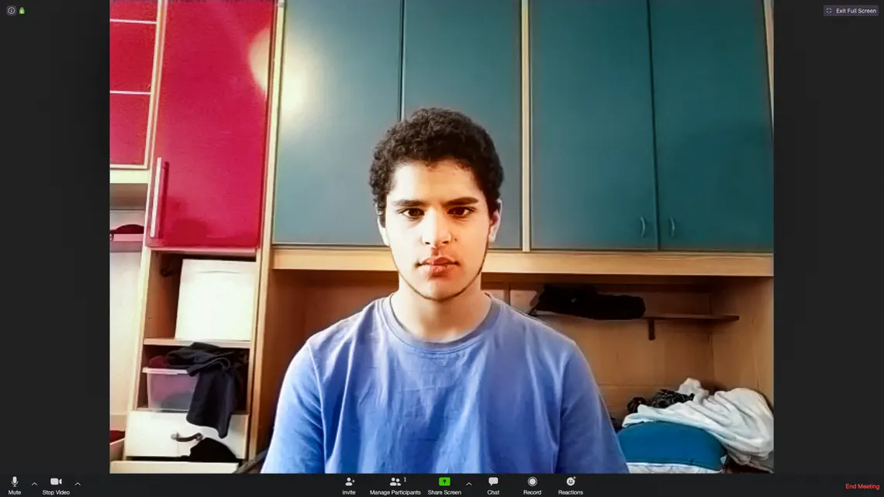
He says: “I consider myself a very sedentary person. Usually during the school holidays, I tend to stay at home most of the time. Quarantine is not affecting what I would normally do with all this extra free time, and I know I must stay at home. One of the things that changed is my schedule. Since I don’t have to wake up at 6 am, I started to wake up later and later, and as a result I ended up having lunch, dinner, and going to bed at least two hours after my usual time, although I should go back to my usual schedule”.

Alice, 16, lives in Rome and has access to a big garden. This makes the quarantine days easier for her. She’s very good at drawing, and she has plans to go to England for a school programme.
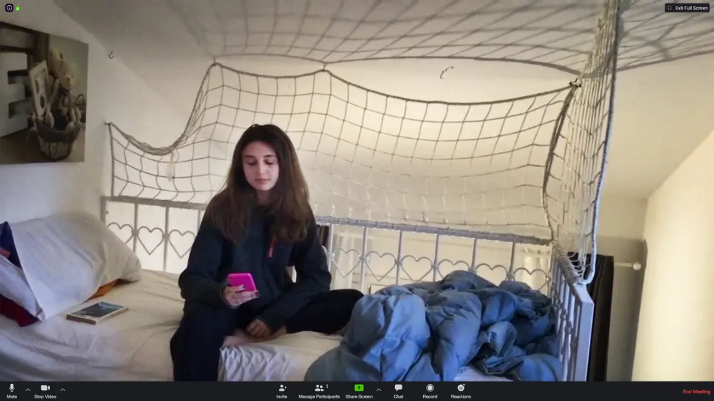
“Staying at home is difficult, more than anything else, because I can’t see my friends in person, but I understand that going out might be dangerous for me and my family. Apart from not going to school and participating in extra-curricular activity, the only different thing is not going out with my friends”.

Chiara connects with the researchers via Zoom and selects her favorite TV series “Money Heist” as a background. She’s very good student and she’s a class representative.
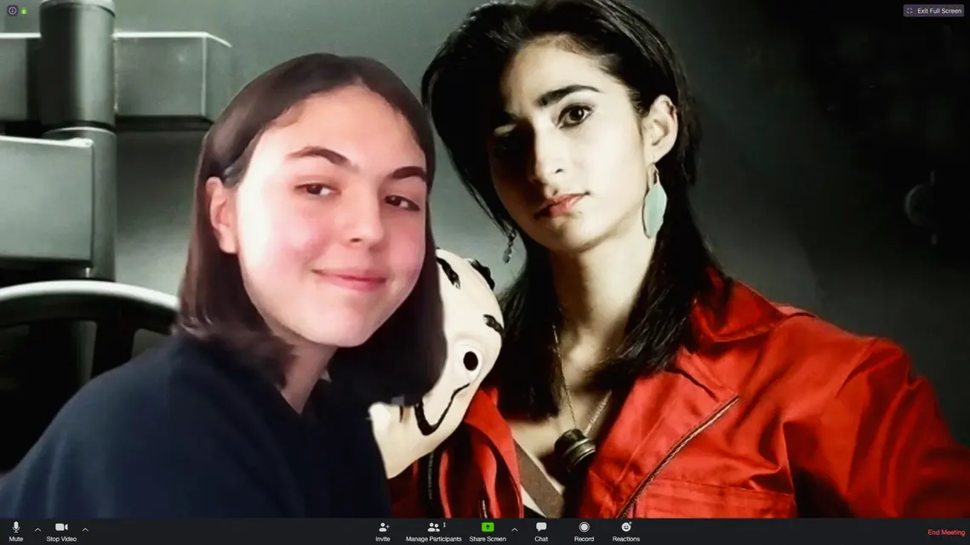
“Obviously I miss my friends and going out, but I get along well with my family and maybe I’ve always been a bit lazy, so adapting wasn’t difficult. Instead of going out with friends, on Saturday nights, I watch movies or series with my family, something nobody had time to do before. I spend most of my days studying, but I also have virtual meetings and chat with my friends, but physically it is different, and I miss that aspect
At first it took me a while to know what was really happening, but I’m optimistic: if we all respect the rules and stay at home, we will be able to get out of this situation”.
Texto adaptado de: https://www.theguardian.com/world/2020/apr/24/how-do-teenagers-live-in-quarantine-photo-essay

- Now, let’s see your comprehension. Can you mention two facts about Rami? For example, that he is 16 years old:
1:_________________________________________
2: ________________________________________

- Now, can you mention three facts about Alice?
1: ____________________________________
2:____________________________________
3:____________________________________
- When the researchers mention Chiara’s favorite TV series, is that a fact? Yes / No Why?

________________________________________________________

- What is an opinion that Rami makes about his schedule?

________________________________________________________

- What possibility does Alice mention in her information?

________________________________________________________

- What is an opinion that Alice makes about the current situation?

________________________________________________________

- When Chiara says “I watch movies or series with my family, something nobody had time to do before”, what does the phrase “nobody had time to do before” mean?

________________________________________________________
- Can you mention something that is similar between any of these Italian teenagers and you?
For example: Like Rami, I also stay at home during the school holidays.

Like _____I________________.

- Can you mention something that is different between any of these Italian teenagers and you?
For example: Unlike Chiara, I’m not a class representative.

Unlike _______ I _____________________

SECTION 3: LET´S CONSTRUCT AND APPLY OUR KNOWLEDGE
- Good job! Now it is time to use your creativity for the following activity:
- Considering that the Covid- 19 is going to change the way we live and interact with people in the future, especially in our country.
- How will coronavirus disease change the way we live?

- Think about what is happening in your community and make up a plan to help with applicable situations.
- For example: organizing turns to look after older people, making masks, etc.
- Now, complete the box below including a list of actions people should do and avoid during Covid 19 pandemic.
- For example:
Do`s | Don`ts
Everybody should wash their hands regularly. | Don´t go to crowded areas or places

b. Make a list of new customs people in Chile might adapt after the Covid-19 pandemic.
- Let your imagination and creativity flow.
- For example:

It might be a custom in Chile in 2025 that people stop kissing each other for greeting. People might shake hands instead.

- It might be custom in Chile in 2022 that people ___________________________________________________
- It might be custom in Chile in the future that people ___________________________________________________

SECTION 4: EXTRA ACTIVITY
- Select some images from social media about how people like doctors, authorities or neighbours are collaborating against Covid 19 in Chile.
- Label them with sentences like “All citizens should help fighting the pandemic by...
- For example: supporting homeless people and avoiding crowded places.
- How would you use this to be able to stop coronavirus disease?

All citizens should help fighting the pandemic by supporting homeless people.


All citizens should help fighting the pandemic by avoiding crowded places.


